**1.Create a Spring Web Project using Maven**

**SpringLearnApplication**

package com.cognizant.springlearn;

import org.slf4j.Logger;

import org.slf4j.LoggerFactory;

import org.springframework.boot.SpringApplication;

import org.springframework.boot.autoconfigure.SpringBootApplication;

@SpringBootApplication

public class SpringLearnApplication {

private static final Logger LOGGER = LoggerFactory.getLogger(SpringLearnApplication.class);

public static void main(String[] args) {

LOGGER.info("START");

SpringApplication.run(SpringLearnApplication.class, args);

LOGGER.info("END");

}

**POM XML**

<?xml version="1.0" encoding="UTF-8"?>

<project xmlns="http://maven.apache.org/POM/4.0.0" xmlns:xsi="http://www.w3.org/2001/XMLSchema-instance"

xsi:schemaLocation="http://maven.apache.org/POM/4.0.0 https://maven.apache.org/xsd/maven-4.0.0.xsd">

<modelVersion>4.0.0</modelVersion>

<parent>

<groupId>org.springframework.boot</groupId>

<artifactId>spring-boot-starter-parent</artifactId>

<version>3.5.3</version>

<relativePath/> <!-- lookup parent from repository -->

</parent>

<groupId>com.cognizant</groupId>

<artifactId>spring-learn</artifactId>

<version>0.0.1-SNAPSHOT</version>

<name>spring-learn</name>

<description>Spring Learn Web App</description>

<url/>

<licenses>

<license/>

</licenses>

<developers>

<developer/>

</developers>

<scm>

<connection/>

<developerConnection/>

<tag/>

<url/>

</scm>

<properties>

<java.version>17</java.version>

</properties>

<dependencies>

<dependency>

<groupId>org.springframework.boot</groupId>

<artifactId>spring-boot-starter-web</artifactId>

</dependency>

<dependency>

<groupId>org.springframework.boot</groupId>

<artifactId>spring-boot-devtools</artifactId>

<scope>runtime</scope>

<optional>true</optional>

</dependency>

<dependency>

<groupId>org.springframework.boot</groupId>

<artifactId>spring-boot-starter-test</artifactId>

<scope>test</scope>

</dependency>

</dependencies>

<build>

<plugins>

<plugin>

<groupId>org.springframework.boot</groupId>

<artifactId>spring-boot-maven-plugin</artifactId>

</plugin>

</plugins>

</build>

</project>

**OUTPUT**

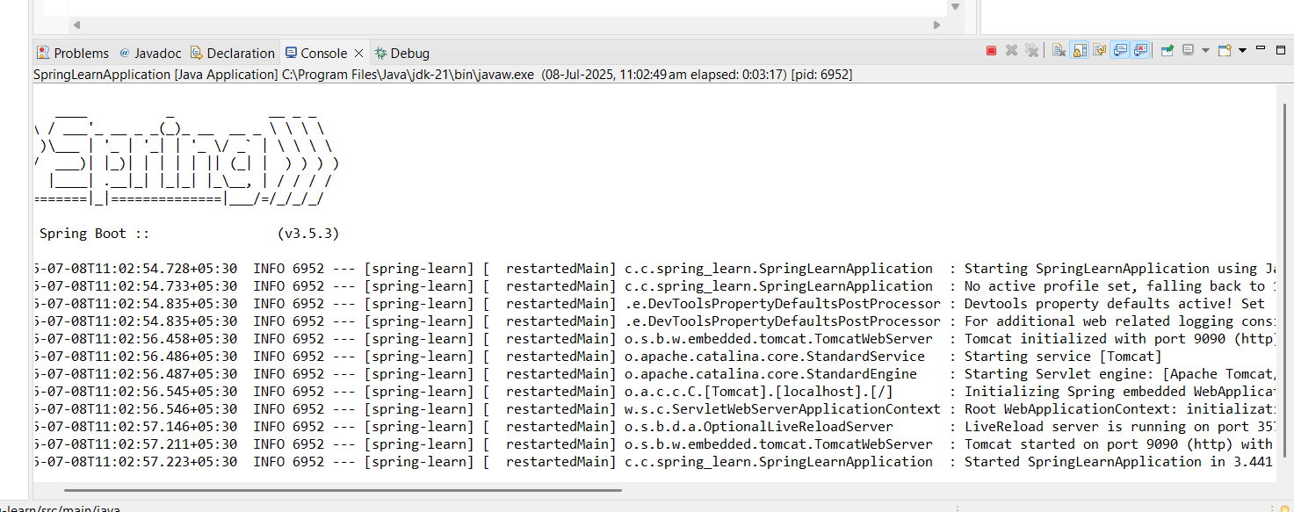

**2.Spring Core – Load Country from Spring Configuration XML**

**Country.java**

package com.cognizant.springlearn;  
  
import org.slf4j.Logger;  
import org.slf4j.LoggerFactory;  
  
public class Country {  
 private static final Logger *LOGGER* = LoggerFactory.*getLogger*(Country.class);  
  
 private String code;  
 private String name;  
  
 public Country() {  
 *LOGGER*.debug("Inside Country Constructor.");  
 }  
  
 public String getCode() {  
 *LOGGER*.debug("Inside getCode()");  
 return code;  
 }  
  
 public void setCode(String code) {  
 *LOGGER*.debug("Inside setCode()");  
 this.code = code;  
 }  
  
 public String getName() {  
 *LOGGER*.debug("Inside getName()");  
 return name;  
 }  
  
 public void setName(String name) {  
 *LOGGER*.debug("Inside setName()");  
 this.name = name;  
 }  
  
 @Override  
 public String toString() {  
 return "Country{" +  
 "code='" + code + '\'' +  
 ", name='" + name + '\'' +  
 '}';  
 }  
}

**SpringLearnApplication.java**

package com.cognizant.springlearn;  
  
import org.slf4j.Logger;  
import org.slf4j.LoggerFactory;  
import org.springframework.context.ApplicationContext;  
import org.springframework.context.support.ClassPathXmlApplicationContext;  
  
public class SpringLearnApplication {  
  
 private static final Logger *LOGGER* = LoggerFactory.*getLogger*(SpringLearnApplication.class);  
  
 public static void main(String[] args) {  
 *LOGGER*.debug("START main()");  
 *displayCountry*();  
 *LOGGER*.debug("END main()");  
 }  
  
 public static void displayCountry() {  
 ApplicationContext context = new ClassPathXmlApplicationContext("country.xml");  
 Country country = context.getBean("country", Country.class);  
 *LOGGER*.debug("Country : {}", country.toString());  
 }  
}

**Main.java**

package org.example;  
  
public class Main {  
 public static void main(String[] args) {  
 System.*out*.printf("Hello and welcome!");  
  
 for (int i = 1; i <= 5; i++) {  
 System.*out*.println("i = " + i);  
 }  
 }  
}

**country.xml**

<?xml version="1.0" encoding="UTF-8"?>  
<beans xmlns="http://www.springframework.org/schema/beans"  
 xmlns:xsi="http://www.w3.org/2001/XMLSchema-instance"  
 xsi:schemaLocation="http://www.springframework.org/schema/beans  
 http://www.springframework.org/schema/beans/spring-beans.xsd">  
  
 <bean id="country" class="com.cognizant.springlearn.Country">  
 <property name="code" value="IN"/>  
 <property name="name" value="India"/>  
 </bean>  
  
</beans>

**POM.XML**

<?xml version="1.0" encoding="UTF-8"?>  
<project xmlns="http://maven.apache.org/POM/4.0.0"  
 xmlns:xsi="http://www.w3.org/2001/XMLSchema-instance"  
 xsi:schemaLocation="http://maven.apache.org/POM/4.0.0 http://maven.apache.org/xsd/maven-4.0.0.xsd">  
  
 <modelVersion>4.0.0</modelVersion>  
  
 <groupId>org.example</groupId>  
 <artifactId>spring-country-booking</artifactId>  
 <version>1.0-SNAPSHOT</version>  
  
 <properties>  
 <maven.compiler.source>21</maven.compiler.source>  
 <maven.compiler.target>21</maven.compiler.target>  
 <project.build.sourceEncoding>UTF-8</project.build.sourceEncoding>  
 </properties>  
  
 <dependencies>  
 <dependency>  
 <groupId>org.springframework</groupId>  
 <artifactId>spring-context</artifactId>  
 <version>5.3.32</version>  
 </dependency>  
  
 <dependency>  
 <groupId>org.slf4j</groupId>  
 <artifactId>slf4j-api</artifactId>  
 <version>1.7.30</version>  
 </dependency>  
  
 <dependency>  
 <groupId>org.slf4j</groupId>  
 <artifactId>slf4j-simple</artifactId>  
 <version>1.7.30</version>  
 </dependency>  
 </dependencies>  
</project>

**OUTPUT**

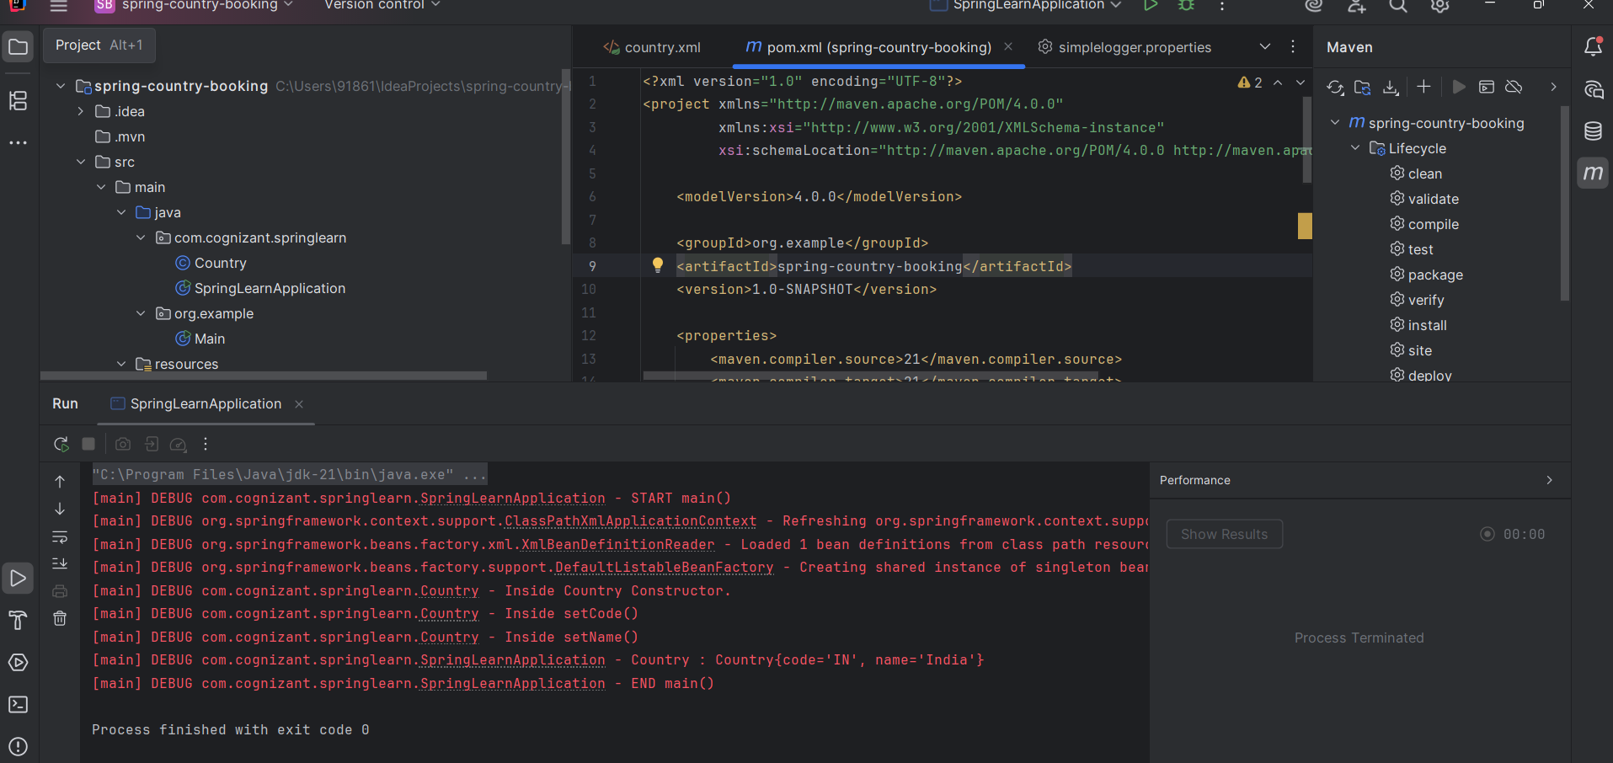

**3.Hello World RESTful Web Service**

**HelloController.java**

package controller;  
  
import org.springframework.web.bind.annotation.GetMapping;  
import org.springframework.web.bind.annotation.RestController;  
  
@RestController  
public class HelloController {  
  
 @GetMapping("/hello")  
 public String sayHello() {  
 return "Hi affu!";  
 }  
}

**SpringApplicationLearn.java**

package controller;  
  
import org.springframework.boot.SpringApplication;  
import org.springframework.boot.autoconfigure.SpringBootApplication;  
  
@SpringBootApplication  
public class SpringLearndemoApplication {  
 public static void main(String[] args) {  
 SpringApplication.*run*(SpringLearndemoApplication.class, args);  
 }  
}

**pom.xml**

<?xml version="1.0" encoding="UTF-8"?>  
<project xmlns="http://maven.apache.org/POM/4.0.0" xmlns:xsi="http://www.w3.org/2001/XMLSchema-instance"  
 xsi:schemaLocation="http://maven.apache.org/POM/4.0.0 https://maven.apache.org/xsd/maven-4.0.0.xsd">  
 <modelVersion>4.0.0</modelVersion>  
 <parent>  
 <groupId>org.springframework.boot</groupId>  
 <artifactId>spring-boot-starter-parent</artifactId>  
 <version>3.5.3</version>  
 <relativePath/> <!-- lookup parent from repository -->  
 </parent>  
 <groupId>com.cognizant</groupId>  
 <artifactId>springlearndemo</artifactId>  
 <version>0.0.1-SNAPSHOT</version>  
 <name>spring learn demo</name>  
 <description>spring learn demo</description>  
 <url/>  
 <licenses>  
 <license/>  
 </licenses>  
 <developers>  
 <developer/>  
 </developers>  
 <scm>  
 <connection/>  
 <developerConnection/>  
 <tag/>  
 <url/>  
 </scm>  
 <properties>  
 <java.version>17</java.version>  
 </properties>  
 <dependencies>  
 <dependency>  
 <groupId>org.springframework.boot</groupId>  
 <artifactId>spring-boot-starter-web</artifactId>  
 </dependency>  
  
 <dependency>  
 <groupId>org.springframework.boot</groupId>  
 <artifactId>spring-boot-starter-test</artifactId>  
 <scope>test</scope>  
 </dependency>  
 </dependencies>  
  
 <build>  
 <plugins>  
 <plugin>  
 <groupId>org.springframework.boot</groupId>  
 <artifactId>spring-boot-maven-plugin</artifactId>  
 </plugin>  
 </plugins>  
 </build>  
  
</project>

**OUTPUT**

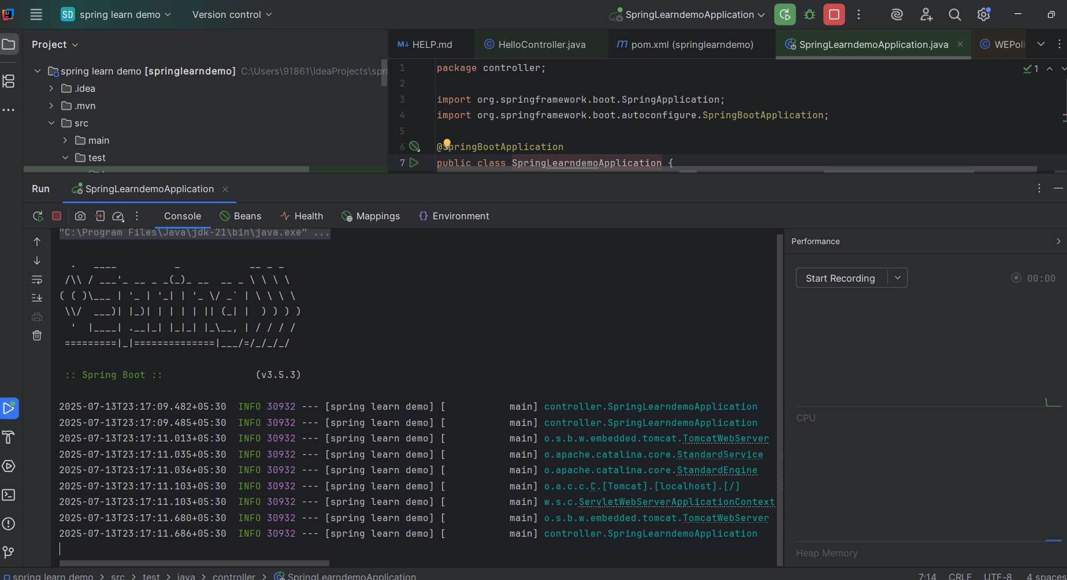

**BROWSER OUTPUT:**

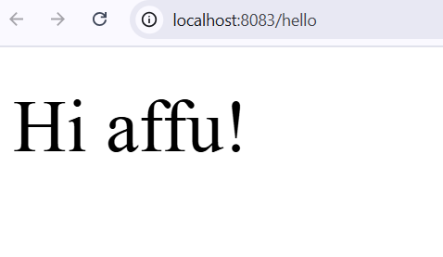

**4.REST - Country Web Service**

**CountryController.java**

package com.cognizant.spring_learn.controller;  
  
  
import com.cognizant.spring_learn.model.Country;  
import org.springframework.context.ApplicationContext;  
import org.springframework.context.support.ClassPathXmlApplicationContext;  
import org.springframework.web.bind.annotation.RequestMapping;  
import org.springframework.web.bind.annotation.RestController;  
  
 @RestController  
 public class CountryController {  
  
 @RequestMapping("/country")  
 public Country getCountryIndia() {  
 ApplicationContext context = new ClassPathXmlApplicationContext("country.xml");  
 Country country = (Country) context.getBean("country");  
 return country;  
 }  
 }

**Country.java**

package com.cognizant.spring_learn.model;  
  
public class Country {  
 private String code;  
 private String name;  
  
 public Country() {}  
  
 public Country(String code, String name) {  
 this.code = code;  
 this.name = name;  
 }  
  
 public String getCode() {  
 return code;  
 }  
  
 public void setCode(String code) {  
 this.code = code;  
 }  
  
 public String getName() {  
 return name;  
 }  
  
 public void setName(String name) {  
 this.name = name;  
 }  
}

**SpringApplicationLearn.java**

package com.cognizant.spring_learn;  
  
import org.springframework.boot.SpringApplication;  
import org.springframework.boot.autoconfigure.SpringBootApplication;  
  
@SpringBootApplication  
public class SpringLearnApplication {  
  
 public static void main(String[] args) {  
 SpringApplication.*run*(SpringLearnApplication.class, args);  
 }  
  
}

**country.xml**

<?xml version="1.0" encoding="UTF-8"?>  
<beans xmlns="http://www.springframework.org/schema/beans"  
 xmlns:xsi="http://www.w3.org/2001/XMLSchema-instance"  
 xsi:schemaLocation="http://www.springframework.org/schema/beans  
 https://www.springframework.org/schema/beans/spring-beans.xsd">  
  
 <bean id="country" class="com.cognizant.spring_learn.model.Country">  
 <property name="code" value="IN" />  
 <property name="name" value="India" />  
 </bean>  
  
</beans>

**Pom.xml**

<?xml version="1.0" encoding="UTF-8"?>  
<project xmlns="http://maven.apache.org/POM/4.0.0" xmlns:xsi="http://www.w3.org/2001/XMLSchema-instance"  
 xsi:schemaLocation="http://maven.apache.org/POM/4.0.0 https://maven.apache.org/xsd/maven-4.0.0.xsd">  
 <modelVersion>4.0.0</modelVersion>  
 <parent>  
 <groupId>org.springframework.boot</groupId>  
 <artifactId>spring-boot-starter-parent</artifactId>  
 <version>3.5.3</version>  
 <relativePath/> <!-- lookup parent from repository -->  
 </parent>  
 <groupId>com.cognizant</groupId>  
 <artifactId>spring-learn</artifactId>  
 <version>0.0.1-SNAPSHOT</version>  
 <name>spring-learn</name>  
 <description>Demo project for Spring Boot</description>  
 <url/>  
 <licenses>  
 <license/>  
 </licenses>  
 <developers>  
 <developer/>  
 </developers>  
 <scm>  
 <connection/>  
 <developerConnection/>  
 <tag/>  
 <url/>  
 </scm>  
 <properties>  
 <java.version>17</java.version>  
 </properties>  
 <dependencies>  
 <dependency>  
 <groupId>org.springframework.boot</groupId>  
 <artifactId>spring-boot-starter-web</artifactId>  
 </dependency>  
  
 <dependency>  
 <groupId>org.springframework.boot</groupId>  
 <artifactId>spring-boot-starter-test</artifactId>  
 <scope>test</scope>  
 </dependency>  
 </dependencies>  
  
 <build>  
 <plugins>  
 <plugin>  
 <groupId>org.springframework.boot</groupId>  
 <artifactId>spring-boot-maven-plugin</artifactId>  
 </plugin>  
 </plugins>  
 </build>  
  
</project>

**OUTPUT**

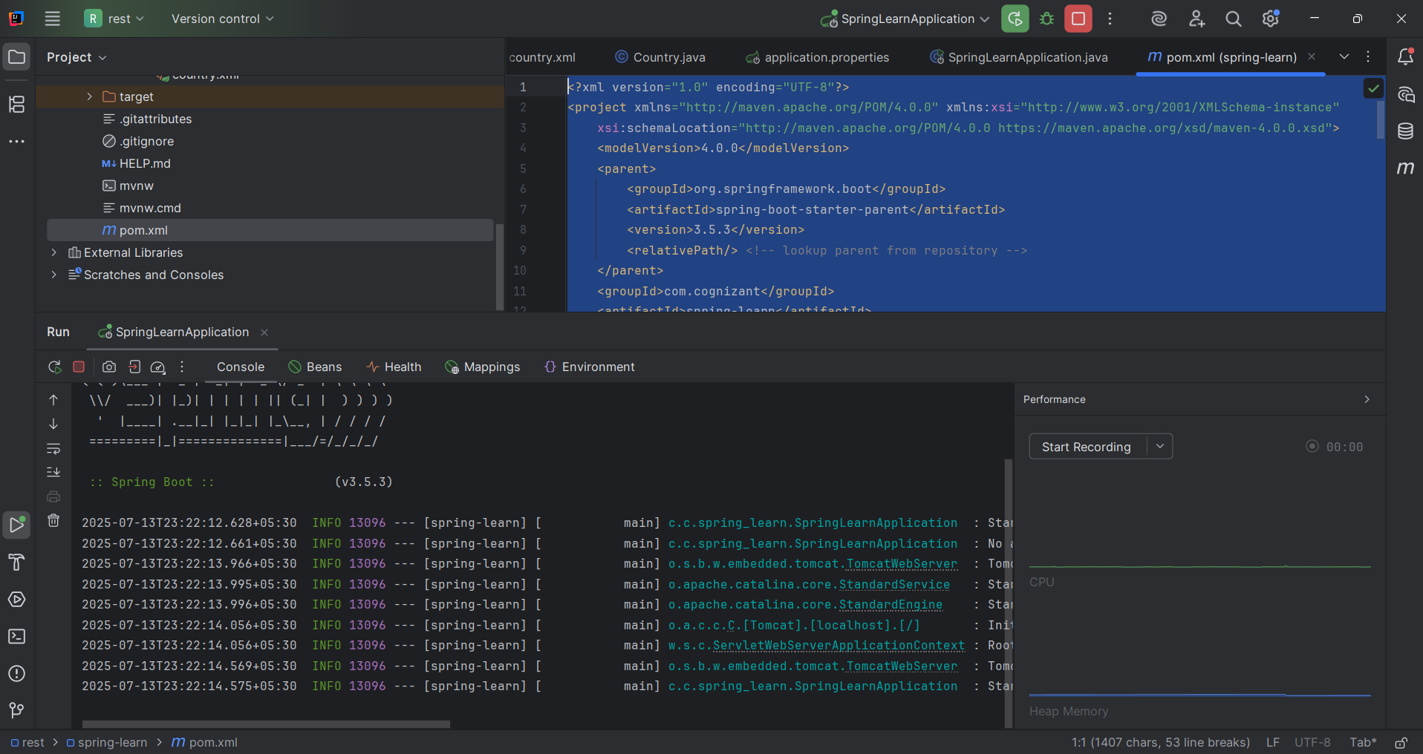

**BROWSER OUTPUT**

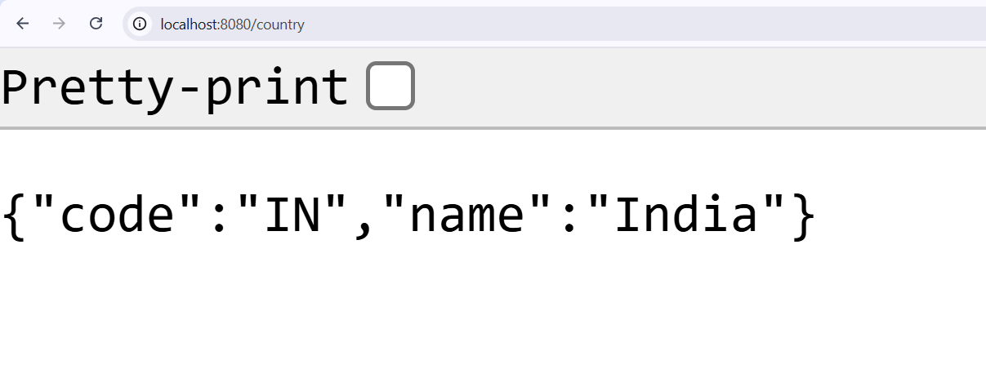

**5.REST - Get country based on country code**

**CountryController.java**

package com.cognizant.spring_learn.controller;  
  
  
import com.cognizant.spring_learn.model.Country;  
import org.springframework.context.ApplicationContext;  
import org.springframework.context.support.ClassPathXmlApplicationContext;  
import org.springframework.web.bind.annotation.RequestMapping;  
import org.springframework.web.bind.annotation.RestController;  
  
 @RestController  
 public class CountryController {  
  
 @RequestMapping("/country")  
 public Country getCountryIndia() {  
 ApplicationContext context = new ClassPathXmlApplicationContext("country.xml");  
 Country country = (Country) context.getBean("country");  
 return country;  
 }  
 }

**Country.java**

package com.cognizant.spring_learn.model;  
  
public class Country {  
 private String code;  
 private String name;  
  
 public Country() {}  
  
 public Country(String code, String name) {  
 this.code = code;  
 this.name = name;  
 }  
  
 public String getCode() {  
 return code;  
 }  
  
 public void setCode(String code) {  
 this.code = code;  
 }  
  
 public String getName() {  
 return name;  
 }  
  
 public void setName(String name) {  
 this.name = name;  
 }  
}

**SpringLearnApplication.java**

package com.cognizant.spring_learn;  
  
import org.springframework.boot.SpringApplication;  
import org.springframework.boot.autoconfigure.SpringBootApplication;  
  
@SpringBootApplication  
public class SpringLearnApplication {  
  
 public static void main(String[] args) {  
 SpringApplication.*run*(SpringLearnApplication.class, args);  
 }  
  
}

**country.xml**

<?xml version="1.0" encoding="UTF-8"?>  
<beans xmlns="http://www.springframework.org/schema/beans"  
 xmlns:xsi="http://www.w3.org/2001/XMLSchema-instance"  
 xsi:schemaLocation="http://www.springframework.org/schema/beans  
 https://www.springframework.org/schema/beans/spring-beans.xsd">  
  
 <bean id="country" class="com.cognizant.spring_learn.model.Country">  
 <property name="code" value="IN" />  
 <property name="name" value="India" />  
 </bean>  
  
</beans>

**Pom.xml**

<?xml version="1.0" encoding="UTF-8"?>  
<project xmlns="http://maven.apache.org/POM/4.0.0" xmlns:xsi="http://www.w3.org/2001/XMLSchema-instance"  
 xsi:schemaLocation="http://maven.apache.org/POM/4.0.0 https://maven.apache.org/xsd/maven-4.0.0.xsd">  
 <modelVersion>4.0.0</modelVersion>  
 <parent>  
 <groupId>org.springframework.boot</groupId>  
 <artifactId>spring-boot-starter-parent</artifactId>  
 <version>3.5.3</version>  
 <relativePath/> <!-- lookup parent from repository -->  
 </parent>  
 <groupId>com.cognizant</groupId>  
 <artifactId>spring-learn</artifactId>  
 <version>0.0.1-SNAPSHOT</version>  
 <name>spring-learn</name>  
 <description>Demo project for Spring Boot</description>  
 <url/>  
 <licenses>  
 <license/>  
 </licenses>  
 <developers>  
 <developer/>  
 </developers>  
 <scm>  
 <connection/>  
 <developerConnection/>  
 <tag/>  
 <url/>  
 </scm>  
 <properties>  
 <java.version>17</java.version>  
 </properties>  
 <dependencies>  
 <dependency>  
 <groupId>org.springframework.boot</groupId>  
 <artifactId>spring-boot-starter-web</artifactId>  
 </dependency>  
  
 <dependency>  
 <groupId>org.springframework.boot</groupId>  
 <artifactId>spring-boot-starter-test</artifactId>  
 <scope>test</scope>  
 </dependency>  
 </dependencies>  
  
 <build>  
 <plugins>  
 <plugin>  
 <groupId>org.springframework.boot</groupId>  
 <artifactId>spring-boot-maven-plugin</artifactId>  
 </plugin>  
 </plugins>  
 </build>  
  
</project>

**OUTPUT**

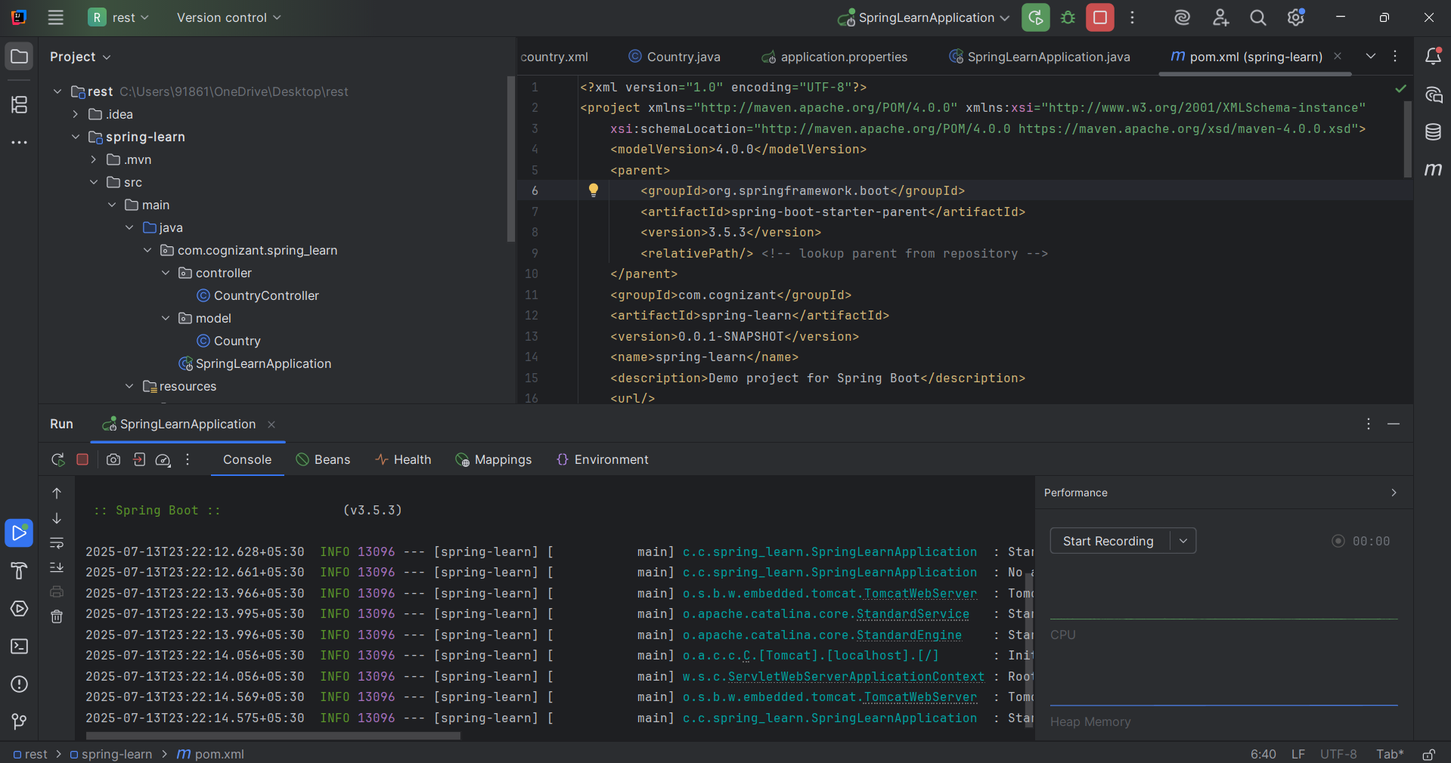

**BROWSER OUTPUT**

